## 

## Bill Splitter

Interactive Design Document

Version: #2

Date: 2023-03-28

Presented by: Silly Beasts

| Team Member 1’s Name | Will Trimble |
| --- | --- |
| Team Member 2’s Name | Glenn Todd |
| Team Member 3’s Name | Ryan Yocum |
| Team Member 4’s Name | Joe Wesnofske |

# Revision History:

2023-03-02: Initial Version for Deliverable #4

2023-03-28: 2. Detailed Design Complete

Be sure to remove any instructional text.

# Conceptual and Intermediate Design

## Sample Persona

### Bill Splitter

Name: Grant McElwain

Background:

College Student

Lives in an apartment with roommates

Does Weekly Grocery Shopping

Goals:

Split the costs of the bill fairly amongst the group.

Get reimbursed for paying a group bill.

Send notifications to everyone within the group regarding the bill.

Attributes:

Seeks tech solutions to everyday problems.

Enjoys exploring new technologies with others.

Values fairness, especially when it comes to money/bills.

## Sketches and Storyboards

### Sketch

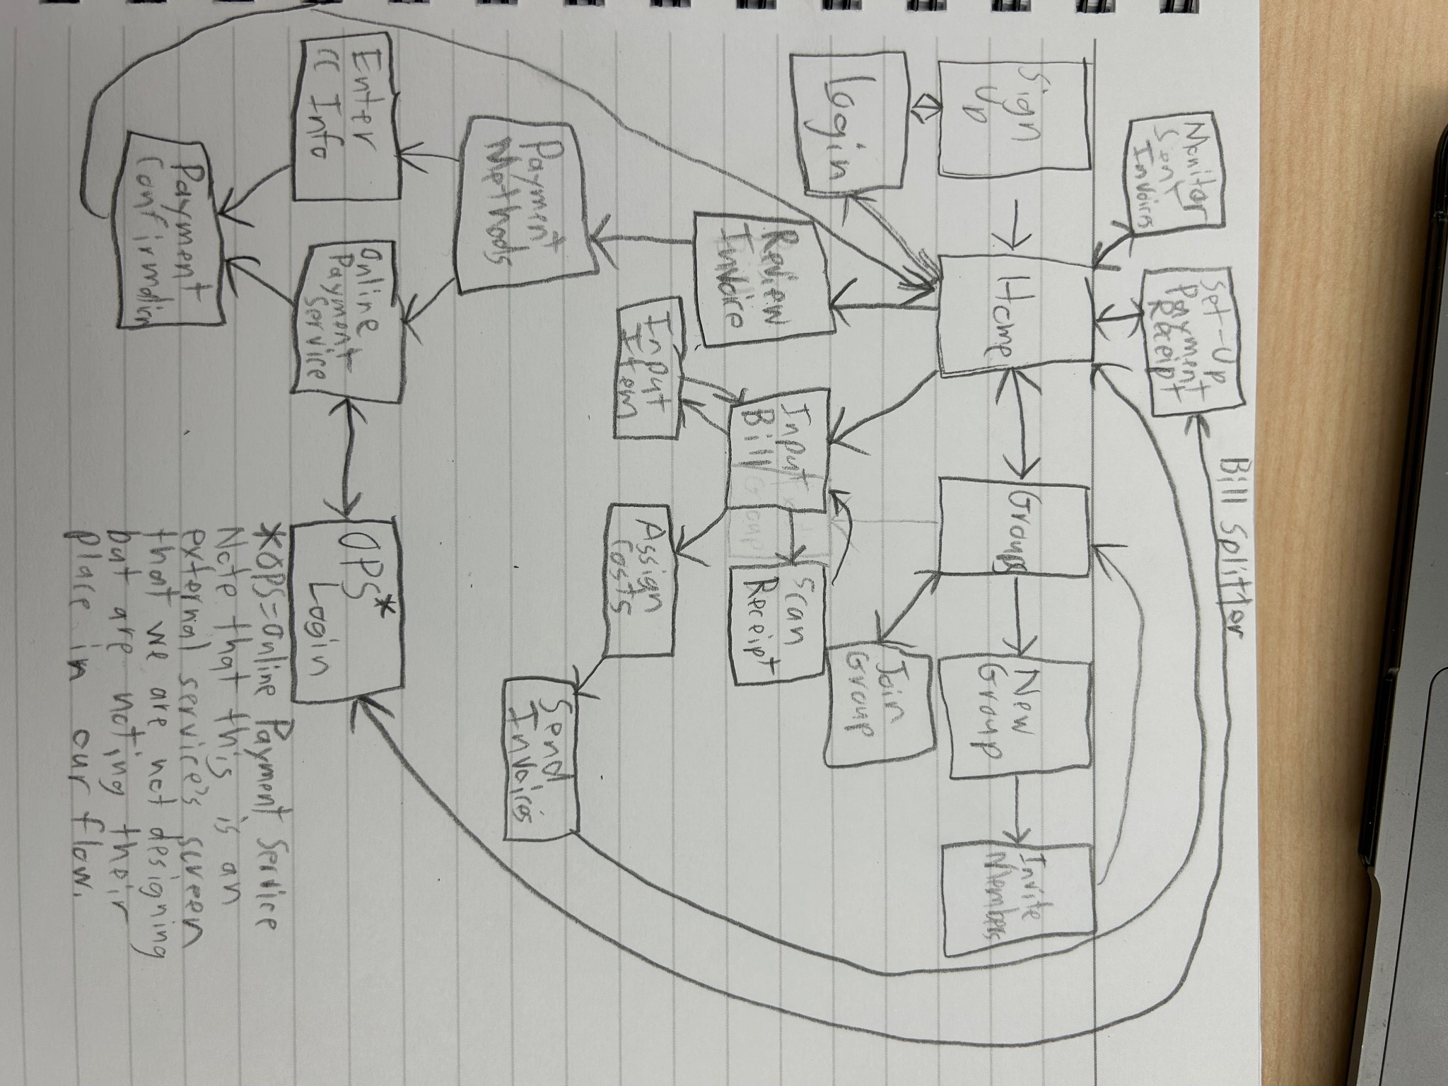

Description: A draft flowchart-esque drawing that shows key actions a user takes in order to accomplish goals using the app. Actions are linked together to show flow from one action to another. Each action is thought of as one screen, with the arrows linking potential screens to each other, although such is not a binding resolution and may be altered later. The realization may have a more omnipresent way to return to home for usability purposes.

### 

### Storyboards

#### Ecological

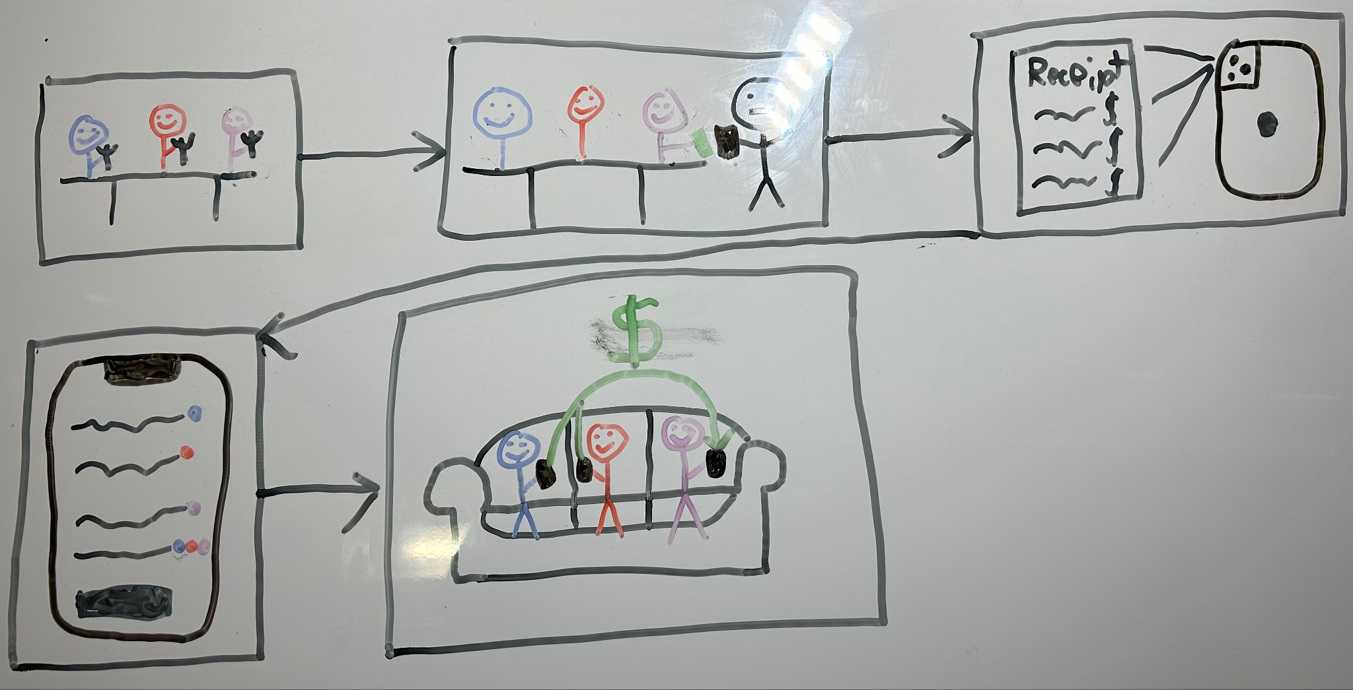

Description: A group of friends are eating a meal at a restaurant together. When presented with the bill, one person pays for the whole group. The receipt is then scanned into the app, and each item is assigned to one or more members of the group. The rest of the group then later uses the app to repay the person who paid the bill at the restaurant. Depictions of certain items and interactions are altered to prioritize interactions in a system over realism

#### Interaction

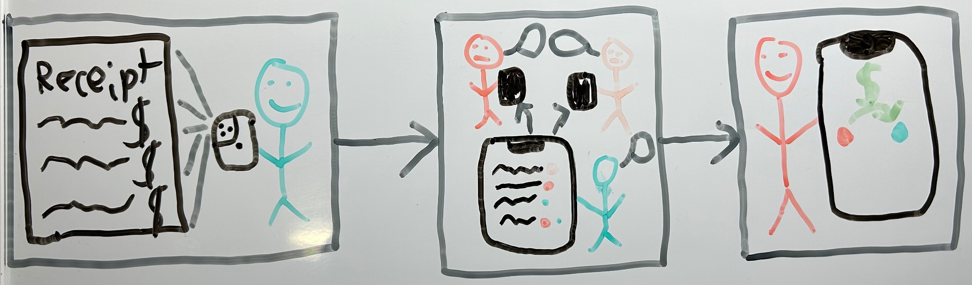

Description: The Bill Splitter (Blue) scans the receipt into the app using the camera on their smartphone. They then discuss the assignment of the costs of the items in the bill with the Bill Payers (Shades of Pink), assigning various items to various people. A Bill Payer then uses the app to repay the Bill Splitter. Objects and people are often not in scale in order to focus on and highlight the important interactional elements in each frame.

#### Emotional

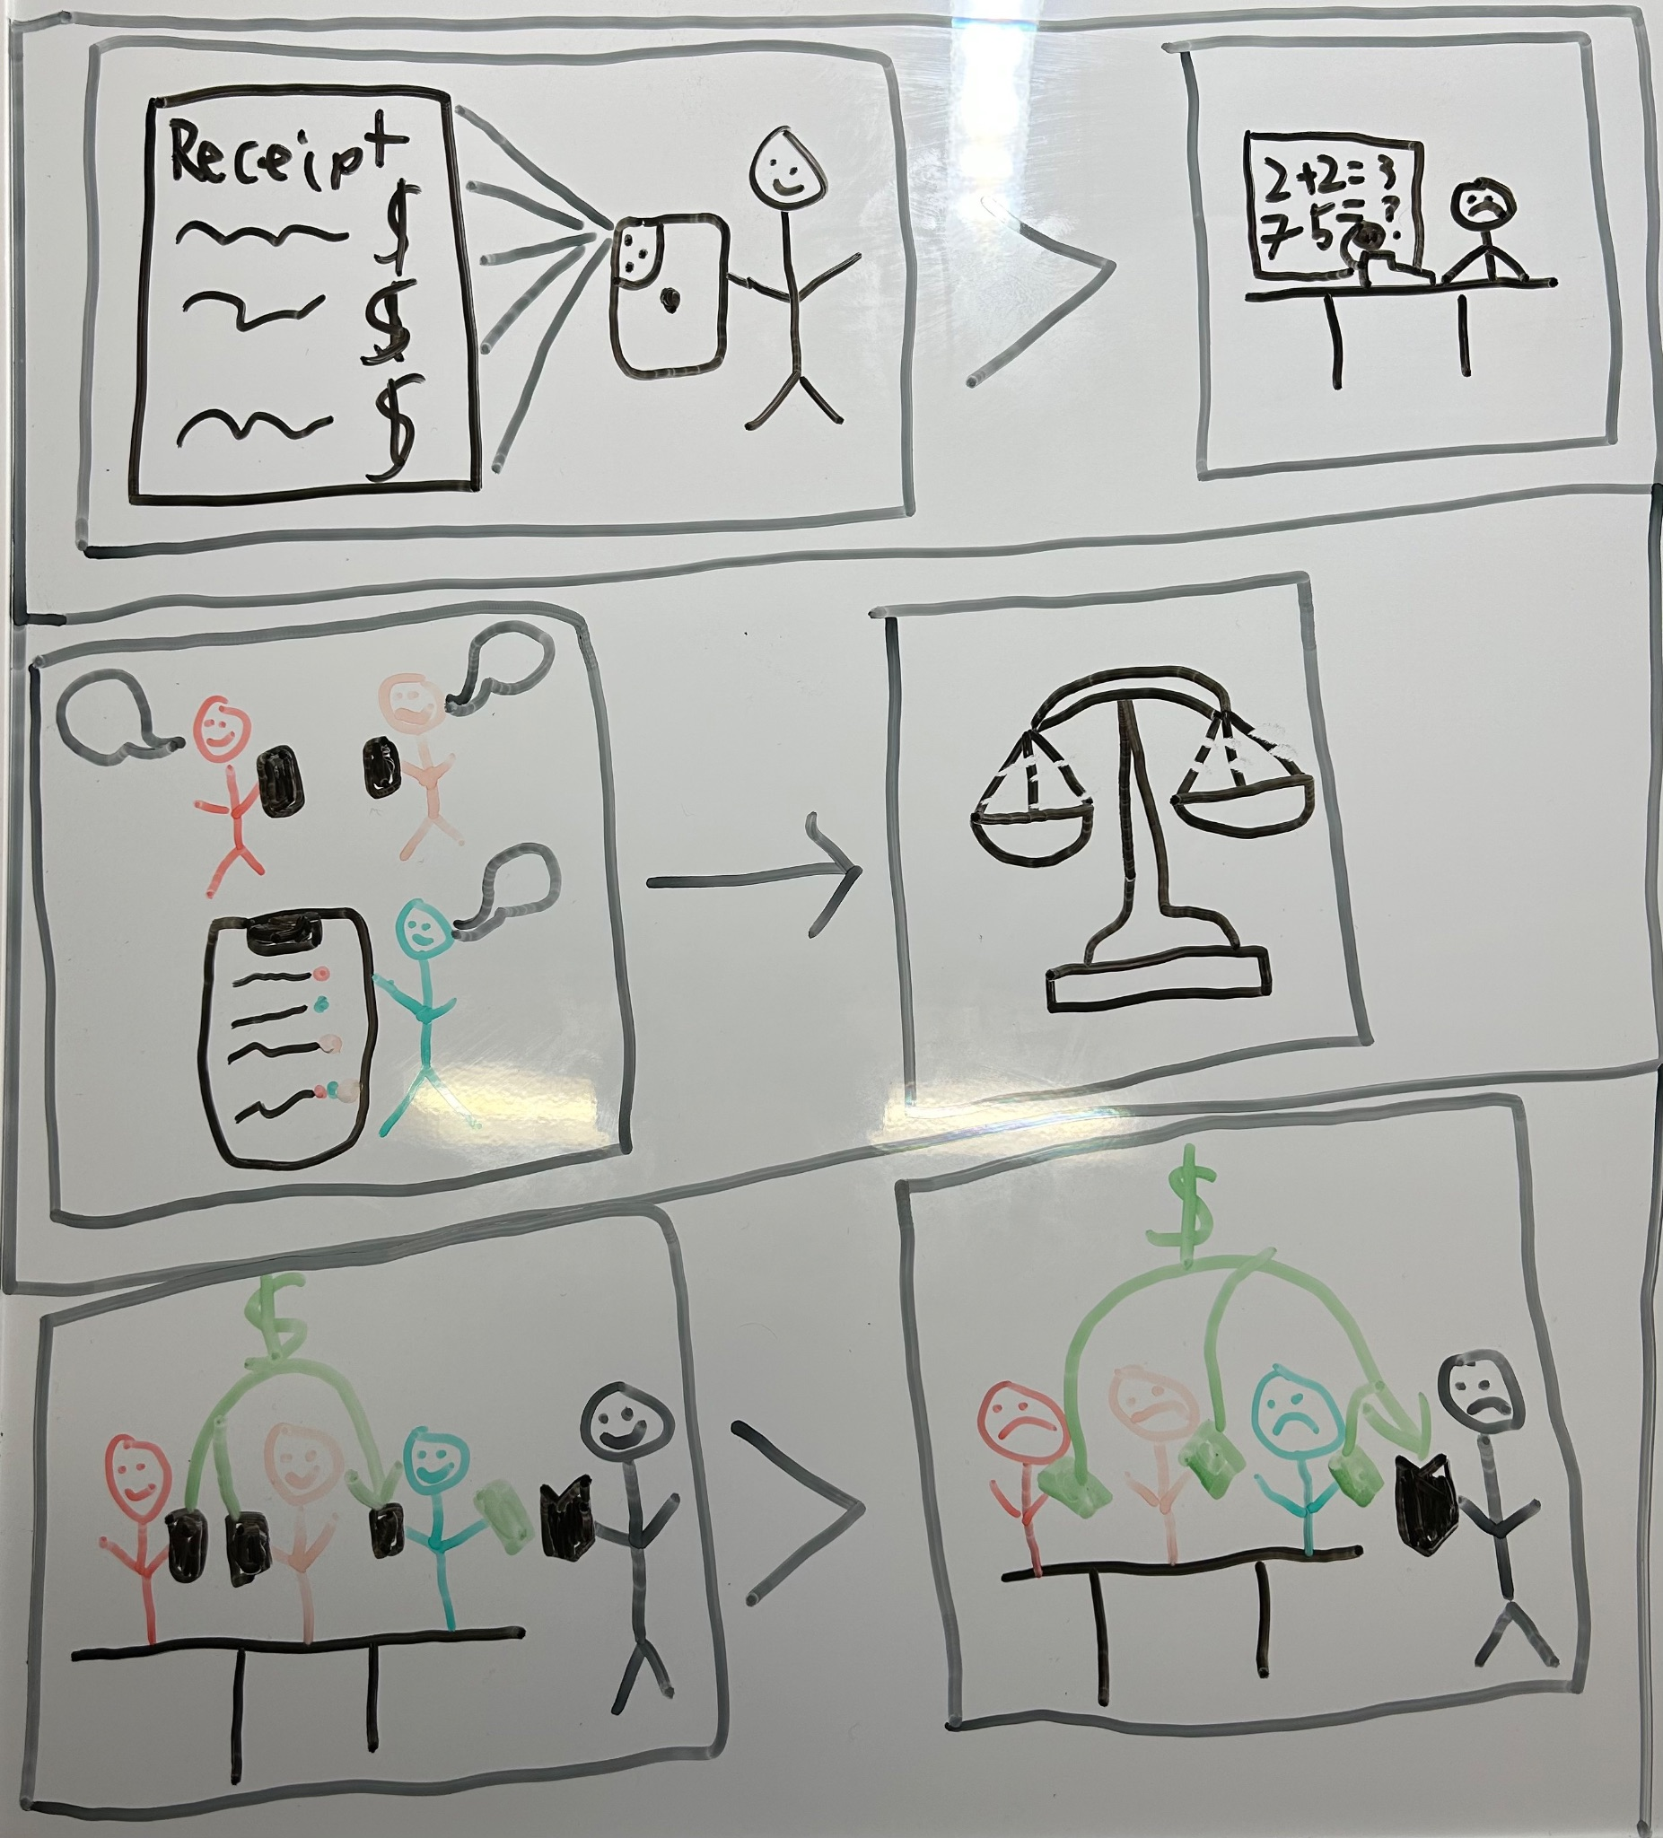

Description: First Row: Scanning a receipt directly into the app is easier than tallying items and crunching the numbers oneself. Second Row: People using the app to discuss and agree upon the way of splitting the costs of the items purchased leads everyone to believe they got a fair deal. Third Row: One person paying the bill at the point of sale and everyone else reimbursing that one person is easier on everyone than having to figure out how to split the bill and each pay individually at the point of sale. Once again, images are abstract to emphasize emotion over realism.

## Wireframes

We started with screens in our app that appear in other apps (login, credit card information, etc.) and model our screen off of good elements from other apps. For example, we used a red badge icon used for notifications to notify users of new invoices to be paid. We then used the design language from those screens to build up other screens with the functionality needed of them. While the colors are not finalized, common colors were used for common elements. For example, we used a red badge icon used for notifications to notify users of new invoices to be paid.

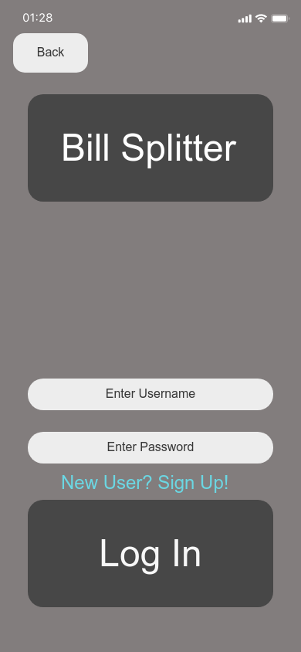

# 

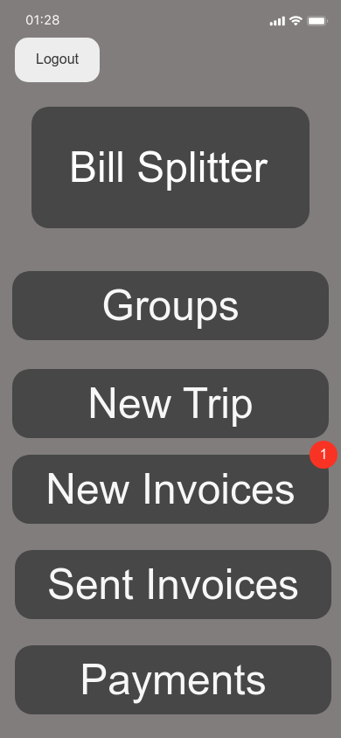

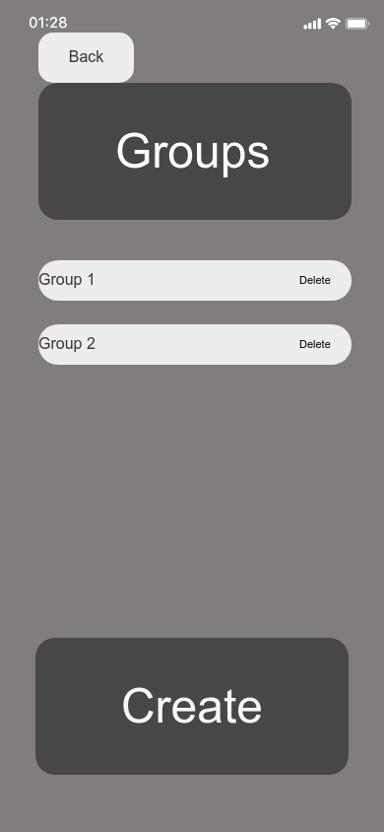

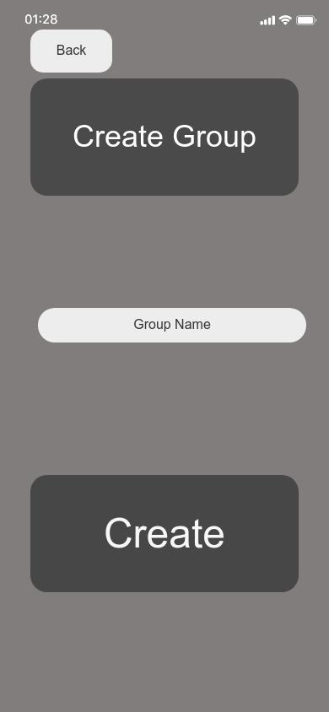

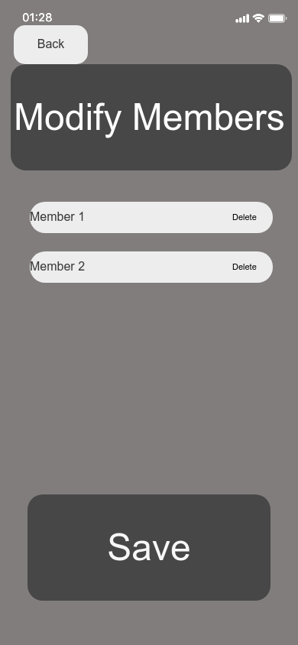

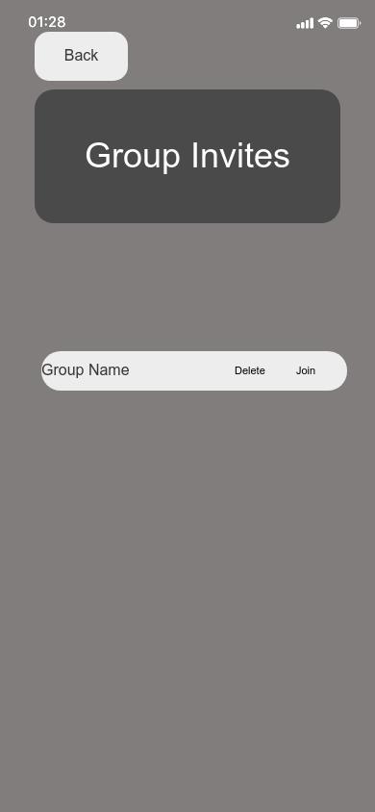

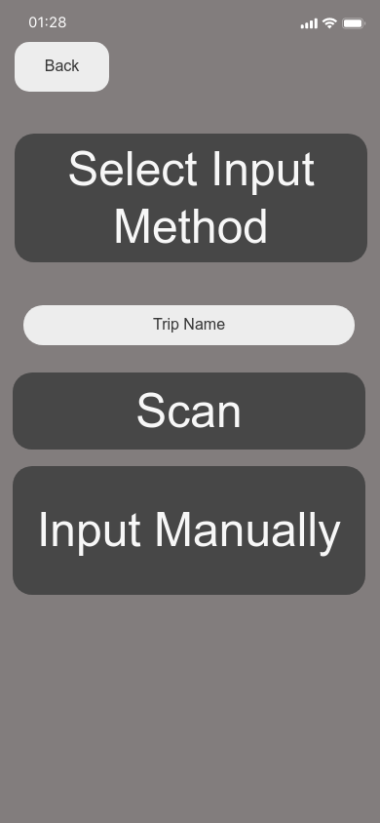

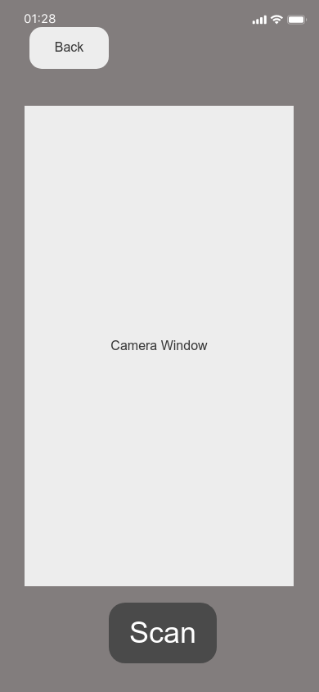

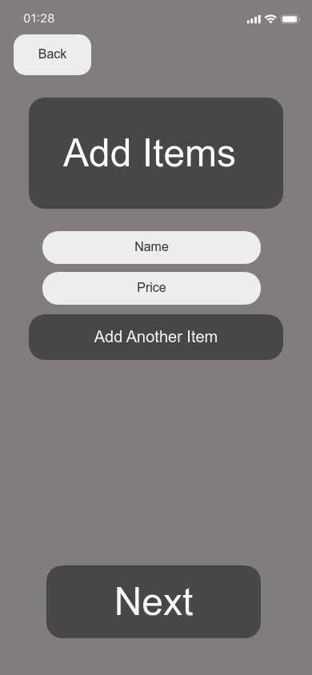

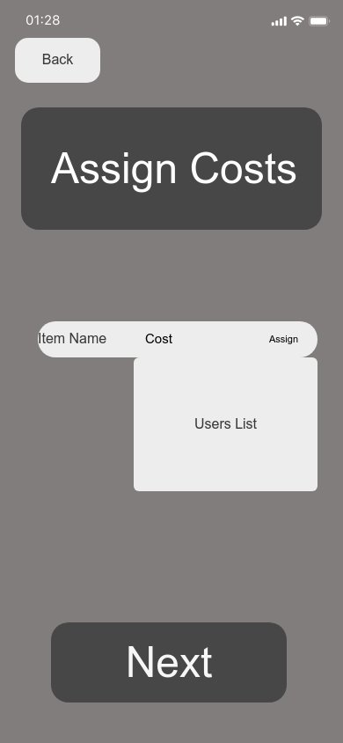

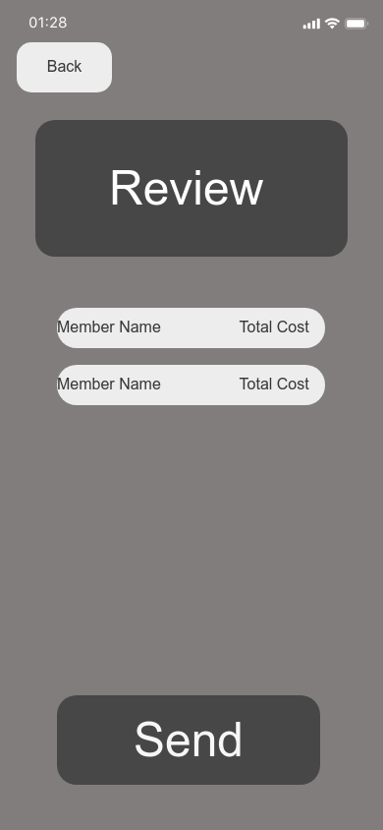

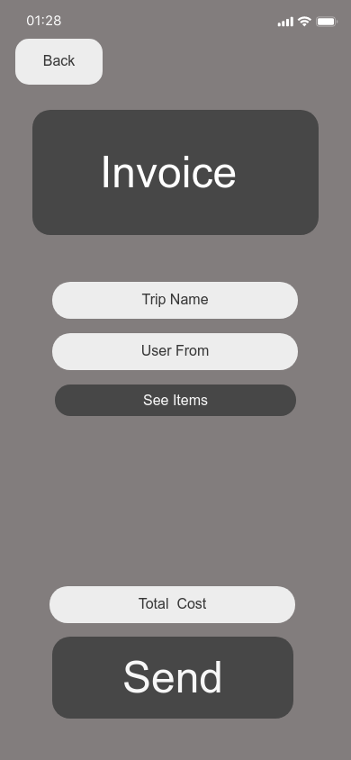

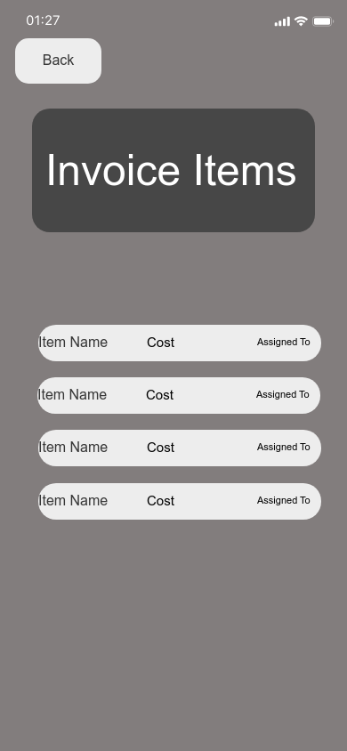

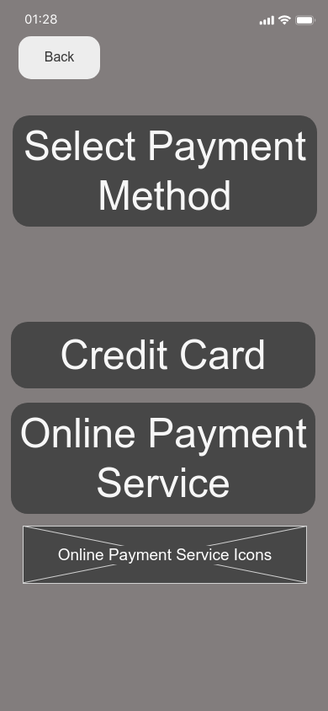

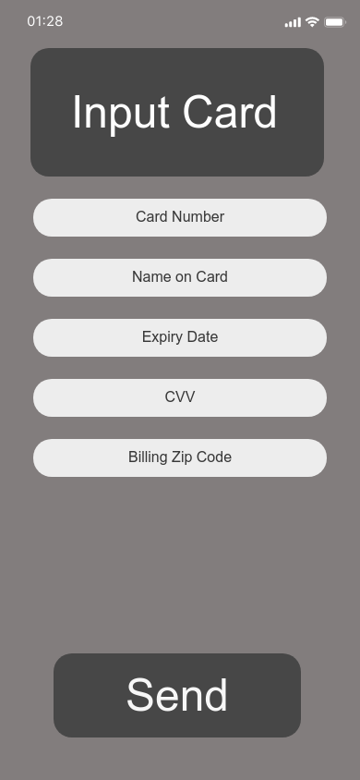

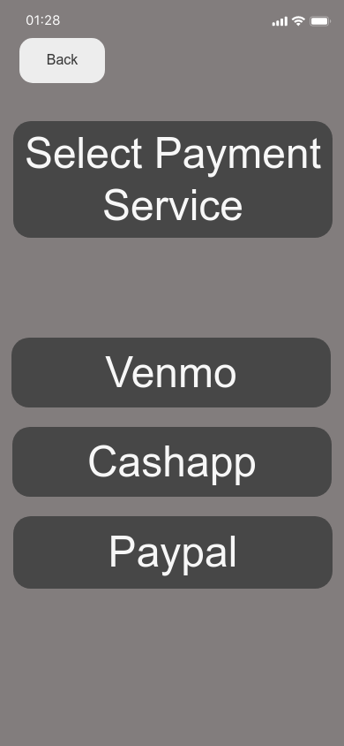

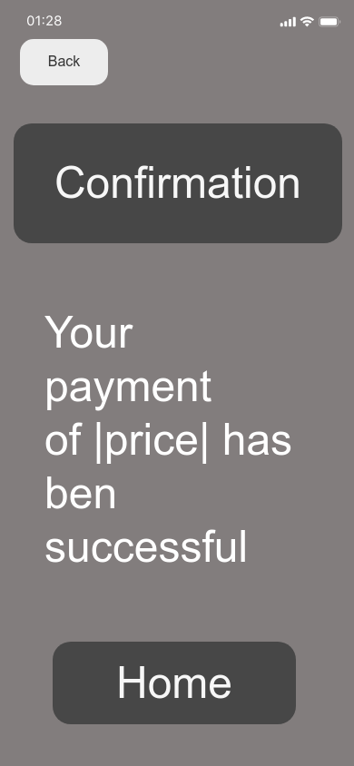

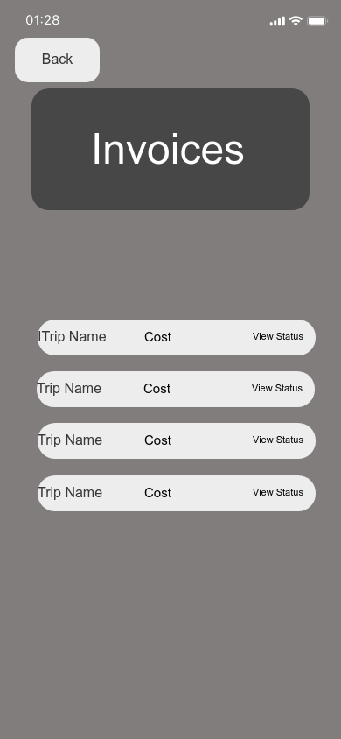

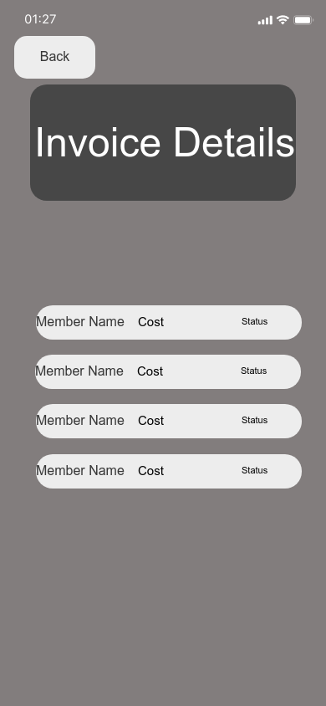

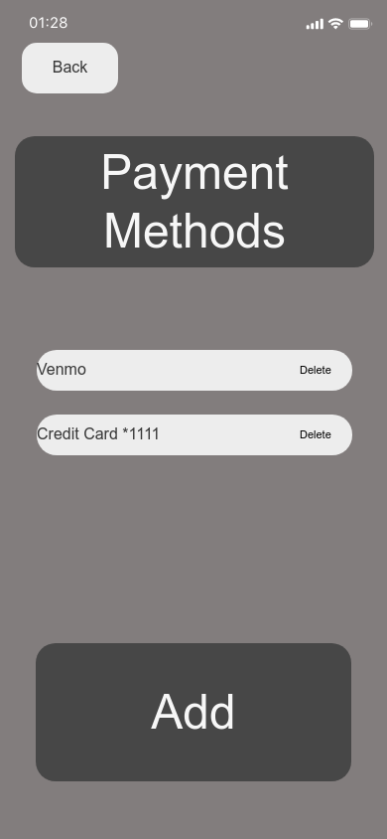

# Detailed Design

[Link to Figma Project](https://www.figma.com/proto/RilQ4nM1sC349wNb3G2RuT/Team-2-Bill-Splitter?node-id=83%3A381)

## Description of the User Interface

ID: 1

Title: Log In

Description: This screen allows the user to log in to the Bill Splitter application. The user can click Remember Me to remember their login, “New User? Sign Up!” redirects the user to create an account, and Log In logs the user into the application.

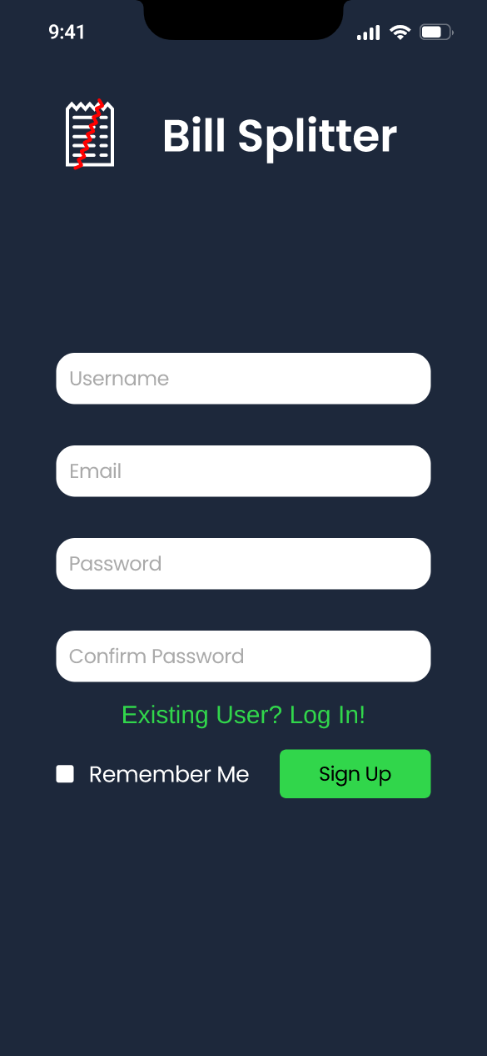

ID: 2

Title: Sign Up

Description: This screen allows the user to create an account for Bill Splitter. They can also click “Existing User? Log In!” to go to the login screen, “Remember Me” to keep themselves logged in, and Sign Up to create and account and sign in.

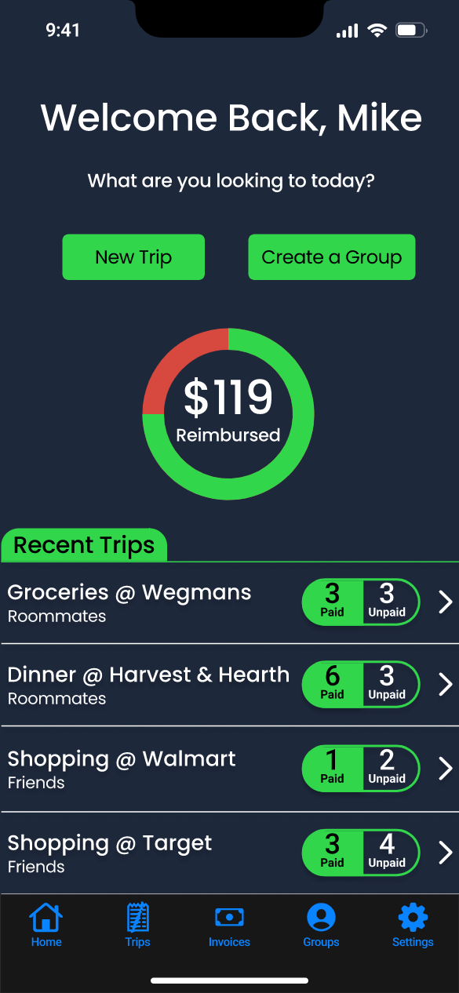

ID: 3

Title: Home

Description: This page gives the user an overview of the current status of the application. It gives the user the option of doing frequent actions such as creating a new trip, or creating a group, as well as view all of the recent trips. The recent trips display how many have paid/not paid, what group it was charged to, and if you click on the trip it will give you more details on the trip..

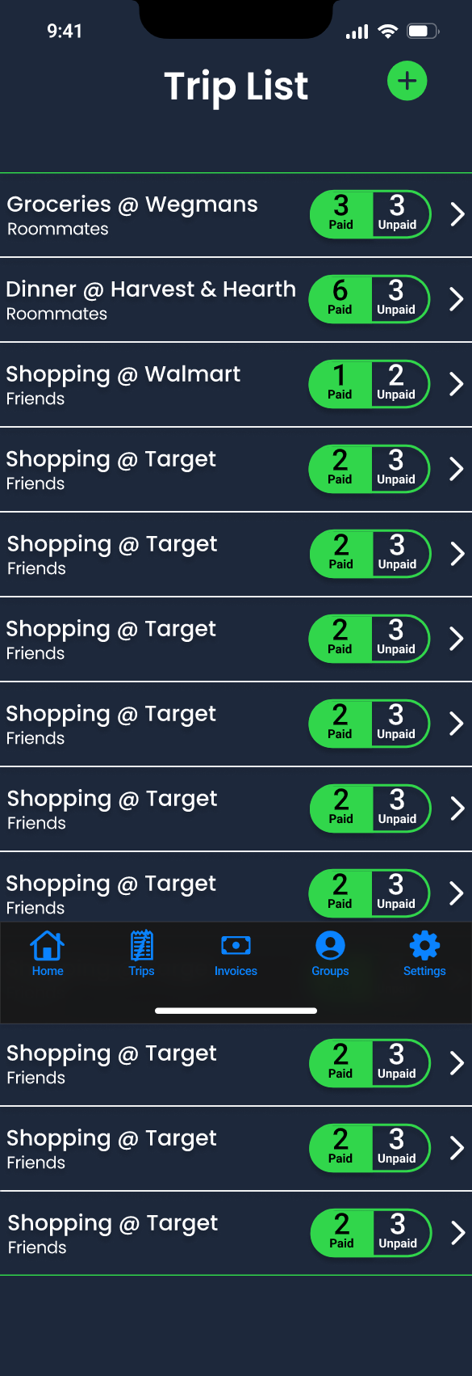

ID: 4

Title: Trip List

Description: This page gives the user a much more full list of what trips they have created and the status on all of them. It also allows the user to click on any one of them to see the the details, as well as create a trip.

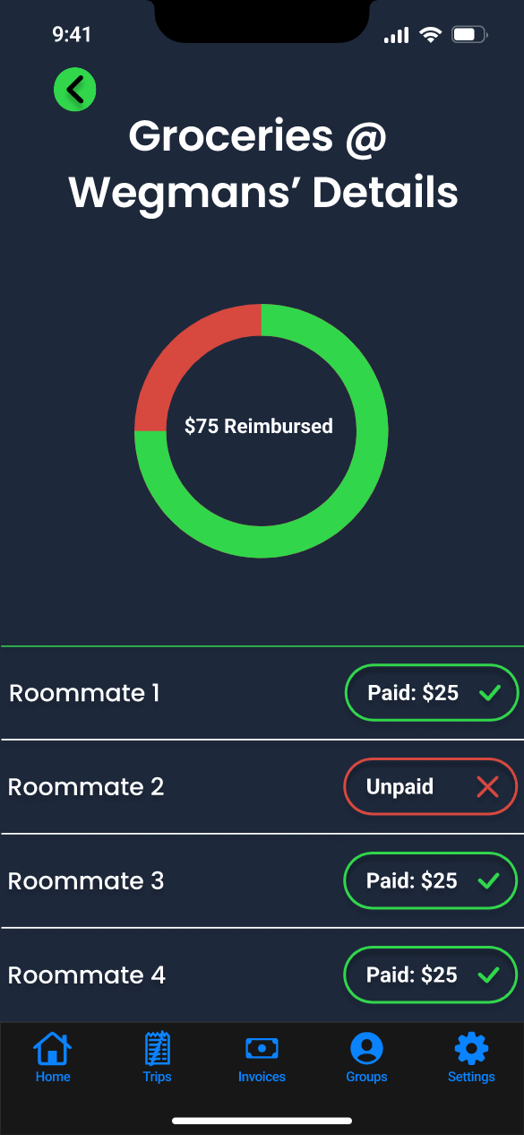

ID: 5

Title: Trip Details

Description: This screen gives the user a much more detailed view of an individual trip, with what users have paid, not paid, and the exact amount.

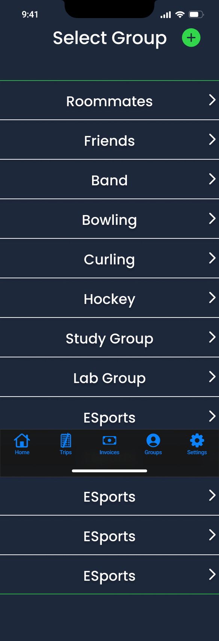

ID: 6

Title: Select Group

Description: This list shows all of the groups, and allows the user to view/modify the group members by clicking on the group, as well as creating a new group.

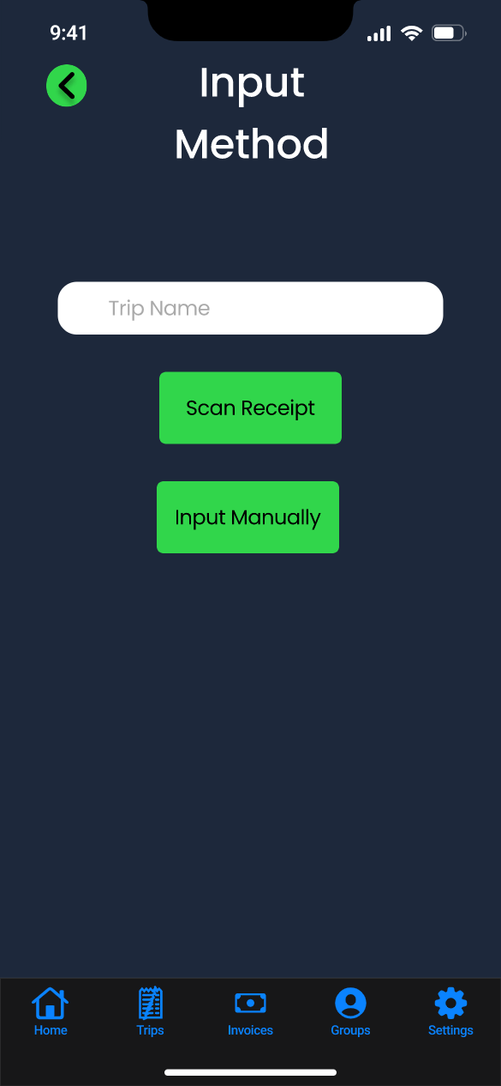

ID: 7

Title: Select Input Method

Description: This screen is the first action that a user sees when creating a new trip, this allows them to give a name to the trip as well as choose whether to scan or input the receipt manually.

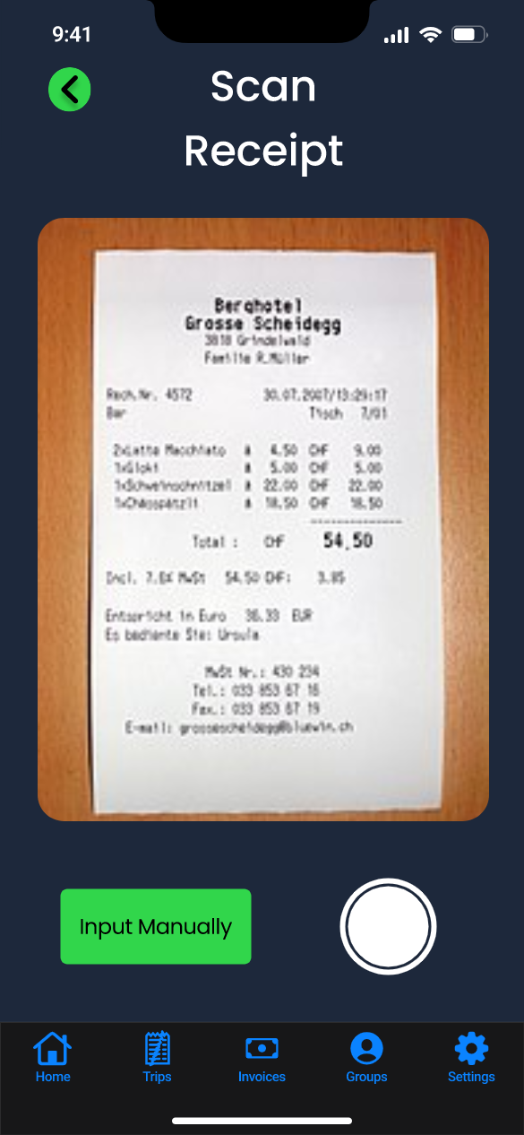

ID: 8

Title: Scan Receipt

Description: This screen allows the user to scan in a receipt, while still giving the user the option to input manually just in case. The camera button captures a photo and reads the receipt details. The user is also given the option to go back in case of a mistake.

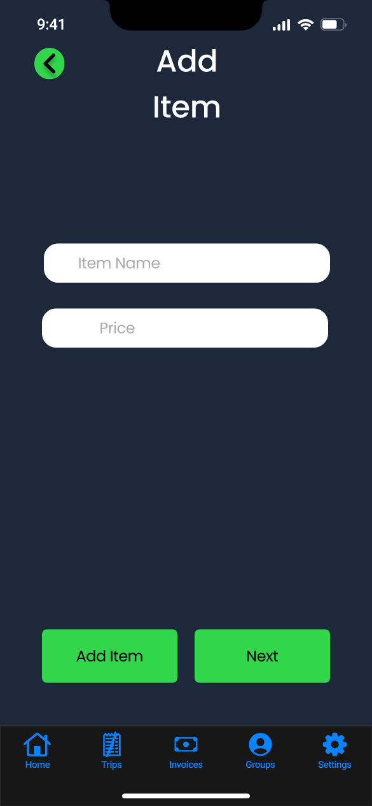

ID: 9

Title: Add Item Manually

Description: This screen provides an alternative to scanning, by manually inputting the item and the price. You can also add an item to that list using the add item button.

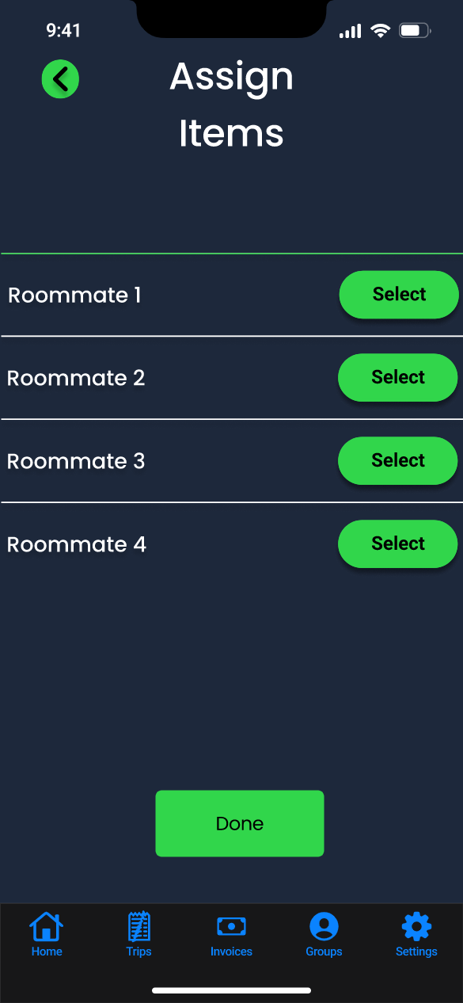

ID: 10

Title: Assign Items

Description: This screen is where the user that created the trip, assigns the items on the trip to individual people. The user can choose the select button, which will redirect them to screen 11, where they choose what to assign to the user. Once they are done, the Done button at the bottom will advance the user. This allows them to distribute the bill evenly according to what was spent by each person from the group.

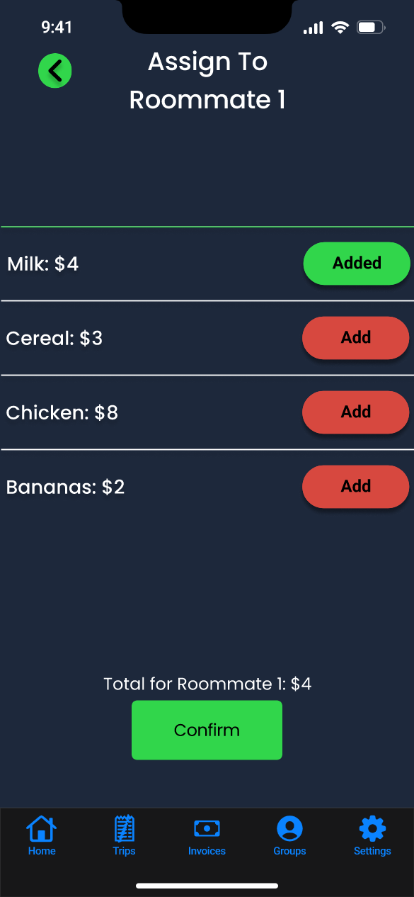

ID: 11

Title: Assign Items To

Description: This screen allows the user to assign items to a user. If there is only one user assigned to an item, then it will put the cost of the bill on that person, though if there are multiple it will split the cost evenly between them. Conform will bring them to the review screen where the user can review their invoice before submitting the invoice.

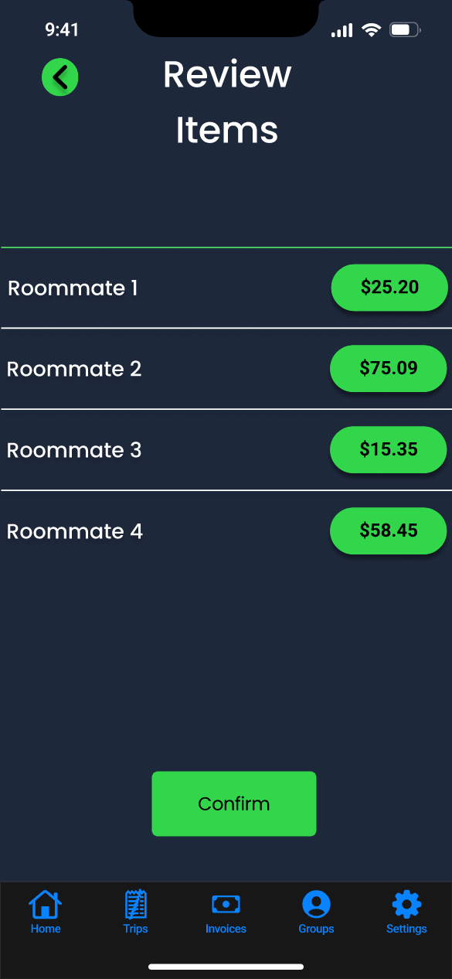

ID: 12

Title: Review Trip

Description: This page gives the user a last chance in case they did something wrong to go back and fix parts of the order, otherwise it is confirmed after they click Confirm. This makes our app less error prone for the user as they can go back and fix their mistakes.

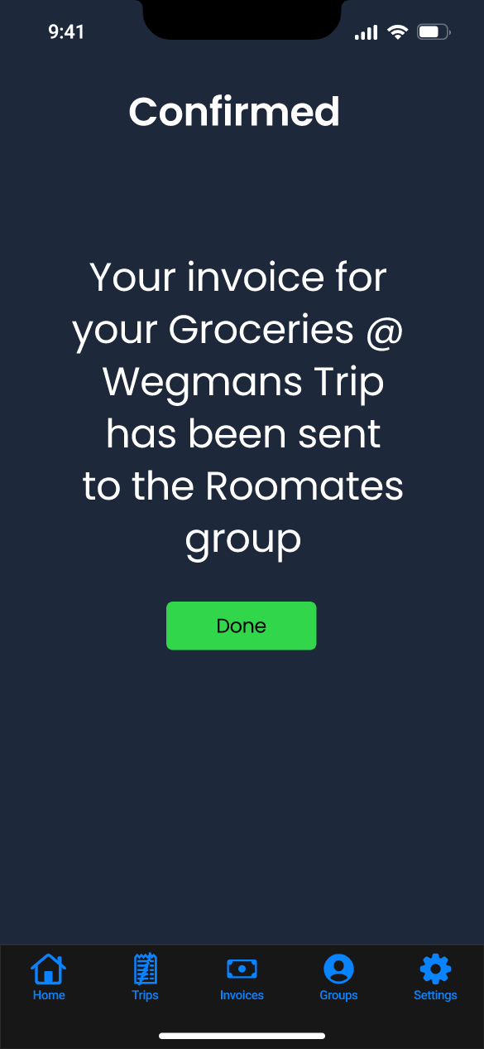

ID: 13

Title: Confirm Trip

Description: This page ensures the user is aware that the trip was confirmed and to what group it was sent to, this makes sure the user is very aware of the action they had done. There is no back button as well, as the user has confirmed their action and at this point they can not return back.

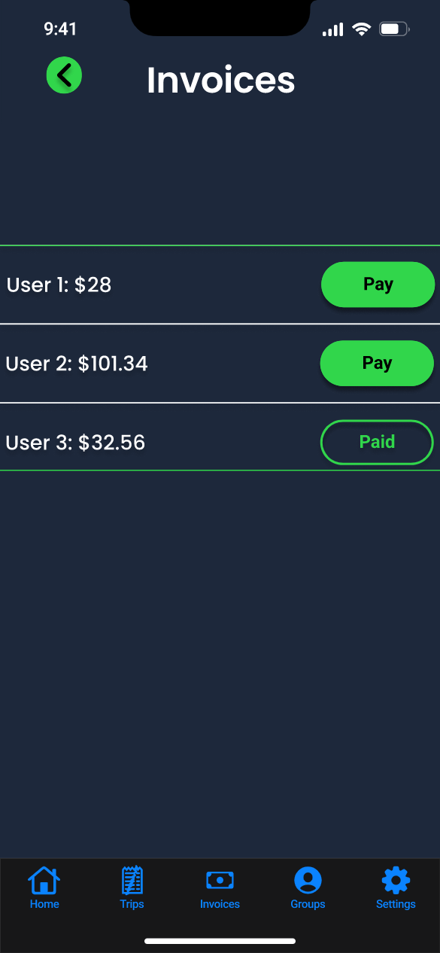

ID: 14

Title: Invoices

Description: This screen is where the user can view the invoices they have gotten from other users of their groups. It allows them to view past and new invoices, and gives them an option to pay, and by clicking that, they will be given the option to pay for that invoice.

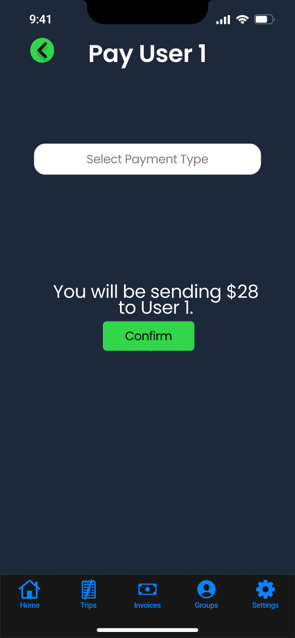

ID: 16

Title: Pay Invoice

Description: To pay the invoice selected on the “Invoices” page, the user selects a payment method, where they are shown their payment options. The user then selects “Confirm” and is taken to the “Payment Confirmation” page. If the user does not wish to pay the invoice at this time, the user can select back to go back to the “Invoices” page or select another top-level page using the toolbar.

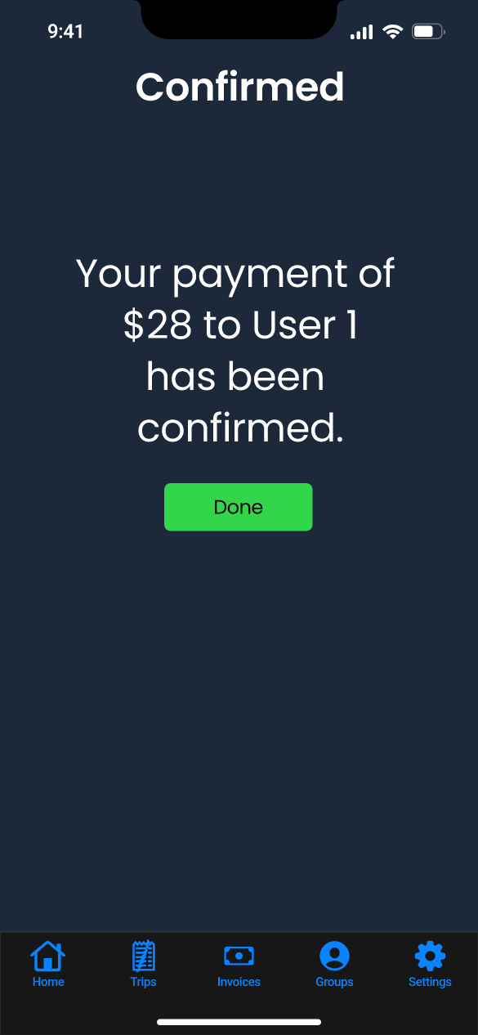

ID: 16

Title: Payment Confirmation

Description: After paying an invoice sent by a user via the “Pay Invoice” page, the user is shown this page as confirmation that the payment has succeeded. The user can select “Done” to return home or select a page in the toolbar.

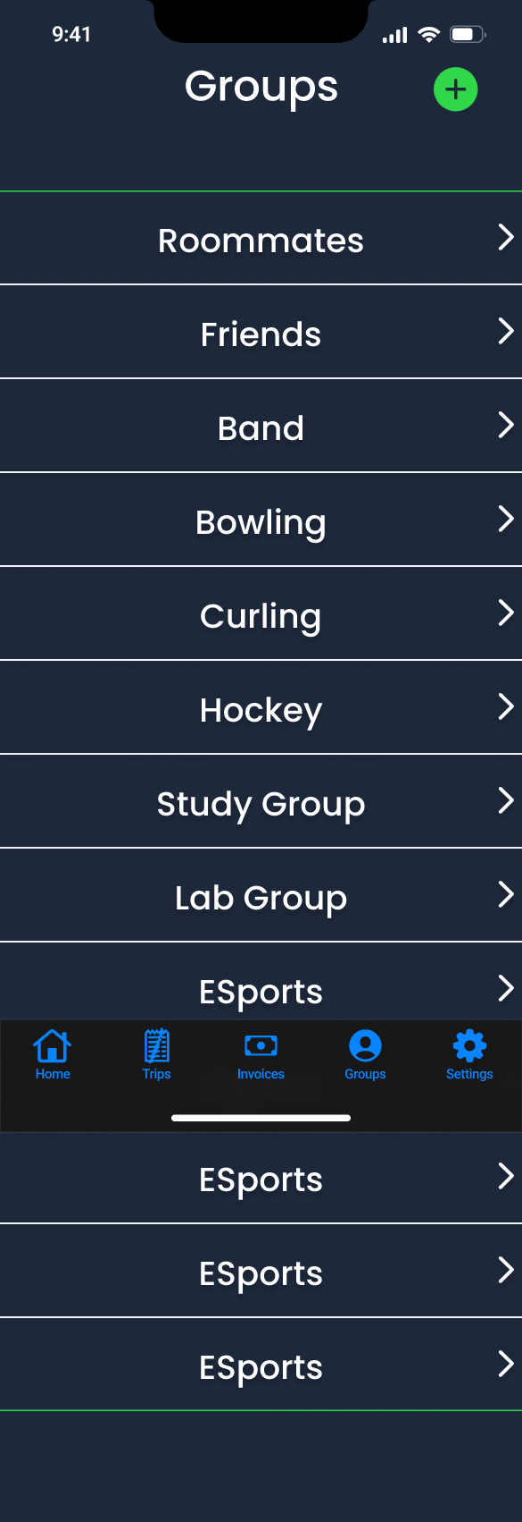

ID: 17

Title: Groups

Description: This screen shows the user’s groups. To create a new group, the user selects the add button to be taken to the “Group Name” page. To manage a group, the user selects a group and is taken to the “Manage Group” page for that group. This page is accessible by “Groups” in the toolbar.

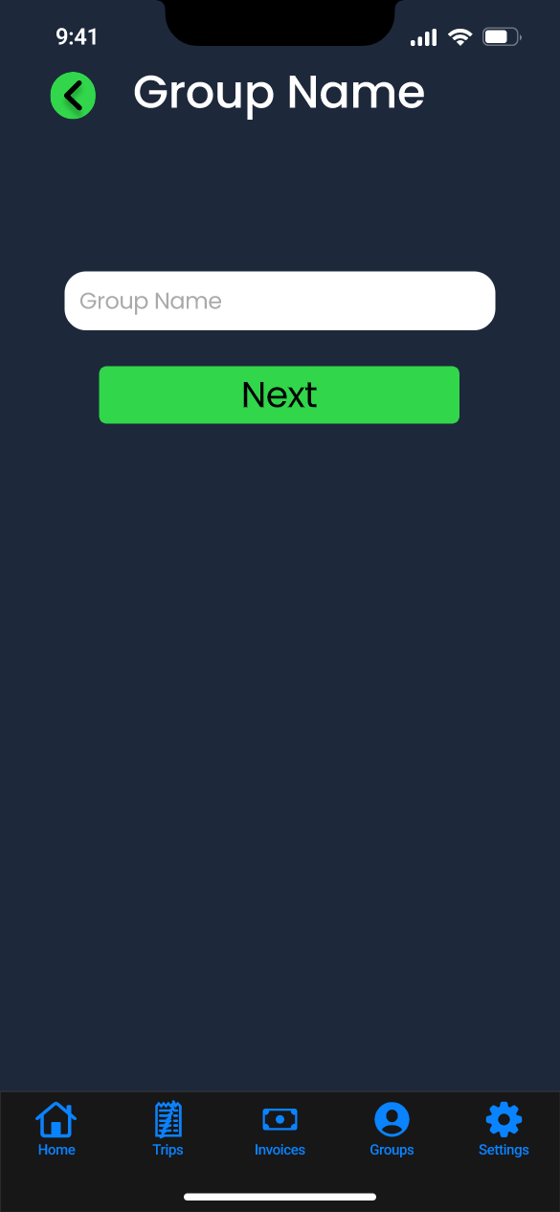

ID: 18

Title: Group Name

Description: The user types a name for their group and selects “Next” to select group type on the “Group Type” page. Selecting back will return the user to the previous screen and cancel group creation.

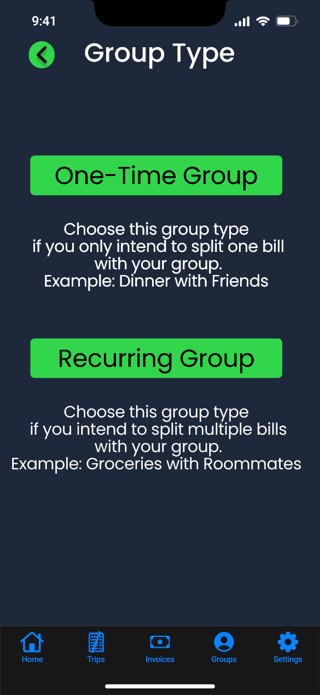

ID: 19

Title: Group Type

Description: After inputting the group’s name on the previous page, “Group Name,” which the user can go back to with the back button, the user selects the group’s type. The user selects “One-Time Group” or “Recurring Group” for the group with the help of instructional text below each choice. Selecting a group type will take the user to the “Manage Group” page for their newly created group, with themself being the only member.

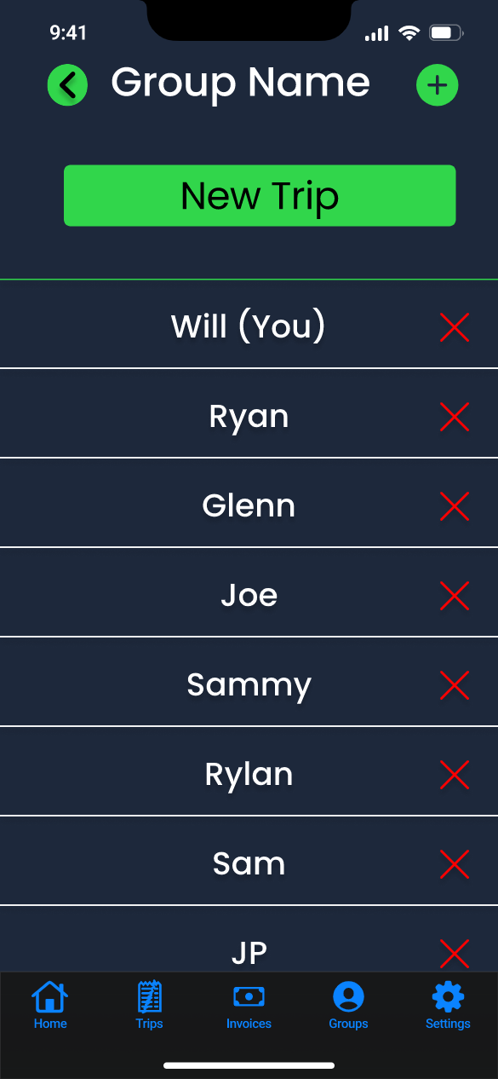

ID: 20

Title: Manage Group

Description: The name of the group is shown at the top. One can add members to the group by the add button in the top-right corner, which takes the user to the “Add Member” page. One can remove a member using the red cross next to their name. One can begin a new trip with the selected group with the “New Trip” button.

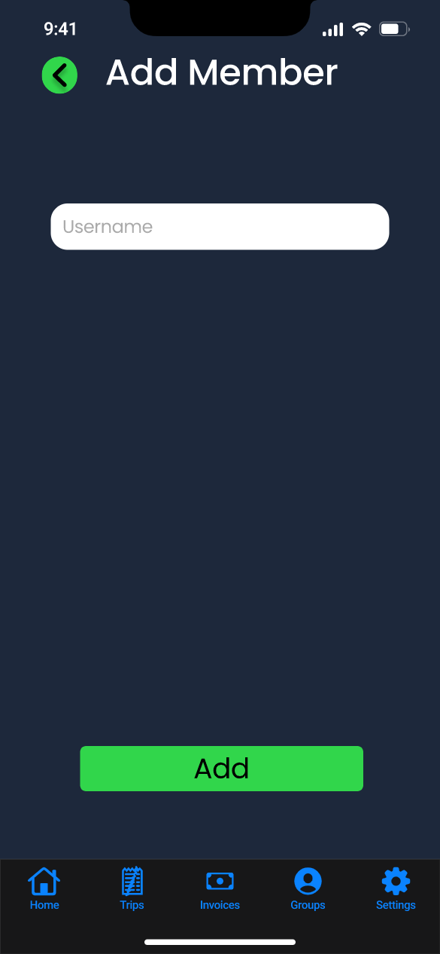

ID: 21

Title: Add Member

Description: One adds a member to a group by typing the member’s username in the text box. As they do, usernames that match appear below the text box that the user can select. When a username is selected, the user can add that member to the group using the “Add” button, which directs them back to the “Manage Group” page. One can also use the back button to return to the “Manage Group” page instead of adding a user.

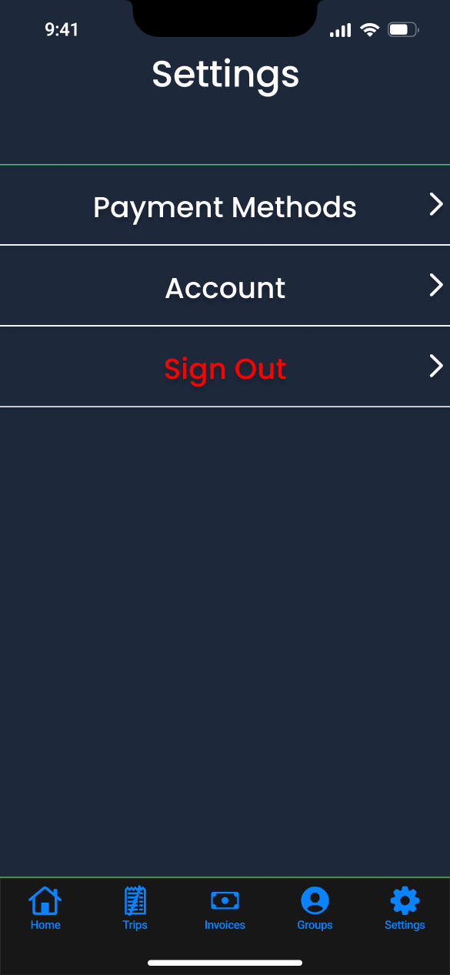

ID: 22

Title: Settings

Description: A user gets to this settings page by the settings button in the toolbar. Payment methods takes them to the Payment Methods screen. Account takes them to a page to manage their account. Sign Out signs out the user and takes them to the Log In page.

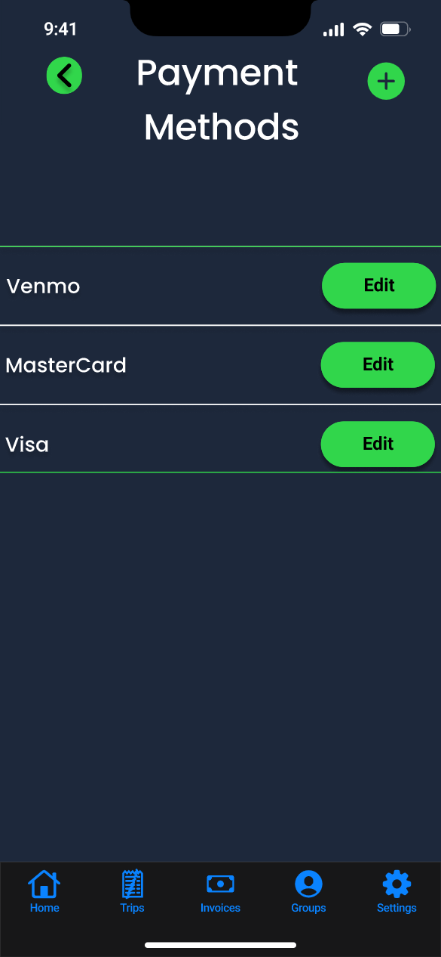

ID: 23

Title: Payment Methods

Description: The screen allows the user to manage how they send and receive payment. The user can edit a payment method with the button next to it. One can add a payment method by hitting the top-right add button. Online payment services are handled by redirecting the user to the service’s screen, which directs them back here when finished. The back button returns the user to the settings page.

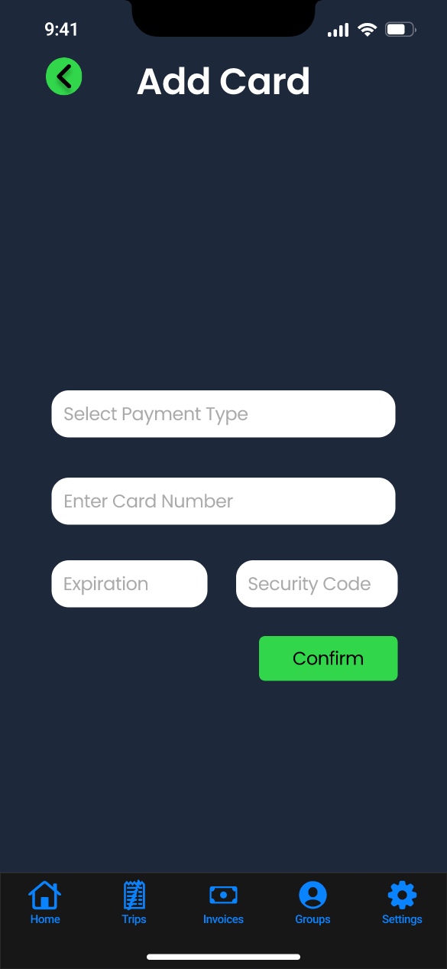

ID: 24

Title: Add Card

Description: This screen allows the user to enter their credit card information to be used to send and receive payment. The user hits the “Confirm” button to add the payment and return to the Payment Methods screen. The user can also return there without adding their credit card information by using the back button. As always, the user can return home or navigate to other top level screens using the bottom toolbar.

## Interface Design Rationale

Our design begins with consistent colors to represent ideas. The background is a dark color to allow bright elements to be visible atop it. The toolbar is a separate color, with its own icon set color, to be visibly distinguished from the rest of the screen. Screens have a title at their top to show the user what page in the application they are in. Pages contain flat buttons with labels to indicate what each button does. Buttons have a solid background fill to distinguish them from other objects that have no interaction. Buttons are either red to indicate no action has occurred with them or green to indicate that an action has or can occur with them. Destructive actions are colored to indicate to give the user pause before pressing them. On the home screen graphics in this case circular progress bars are also shown to give the user an overall status of the application.

All buttons are large enough to be easily pressed on mobile devices. Smaller buttons have icons in addition to text to show their purpose. Generally, the back button is in the top left, the add button is in the top right, and the next button is in the bottom right, with a descriptive label where appropriate. Native iOS UI elements are used when available.

The terminology of “trips” and “invoices” are used to reflect real-world terminology of what is occurring. Review and confirmation screens are shown when sending or requesting payment to ensure users take the correct action and are confident in its success.